Custom leader email banner templates can be found here.

Month 2023 (Optional)
Header (Arial 14pt Evergreen)
Body copy is Arial 12pt Gray 4. Use the approved GE Vernova brand RGB colors throughout, choosing one color per email. Approved colors are as follows: Evergreen (R0/G94/B96), Grey 3 (R204/G204/B204), Grey 4 (R105/G105/B105) and Gray 5 (R72/G72/B72).
Accent color (use selectively): Urgency Green (R200/G255/B8).

Use horizontal rule lines to separate sections of content
On the Table Tools ribbon, click the “Table Design” tab. Set your Pen Color to an approved GE Vernova color, and with the “Borders” drop down, insert a line above or below the desired paragraph.
Formatting in email
Create your content in this template and copy and paste into a new email. You may need to move the photo around and lock it once in place to keep it from reflowing the body text.
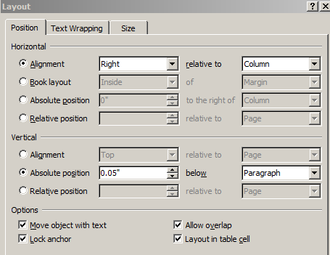
GE Vernova Internal Use Only


Month 2023 (Optional)
Header (Arial 14pt Evergreen)
Body copy is Arial 12pt Gray 4. Use the approved GE Vernova brand RGB colors throughout, choosing one color per email. Approved colors are as follows: Evergreen (R0/G94/B96), Grey 3 (R204/G204/B204), Grey 4 (R105/G105/B105) and Gray 5 (R72/G72/B72).
Accent color (use selectively): Urgency Green (R200/G255/B8).

Use horizontal rule lines to separate sections of content
On the Table Tools ribbon, click the “Table Design” tab. Set your Pen Color to an approved GE Vernova color, and with the “Borders” drop down, insert a line above or below the desired paragraph.
Formatting in email
Create your content in this template and copy and paste into a new email. You may need to move the photo around and lock it once in place to keep it from reflowing the body text.
GE Vernova Internal Use Only

